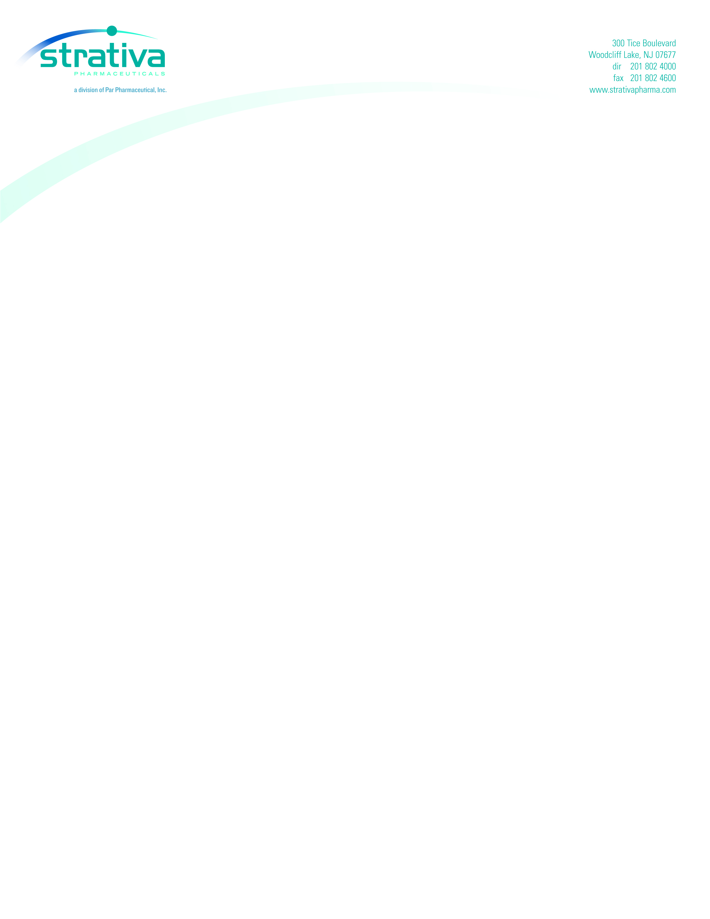
Re: Managed Care Update for Megace® ES

Dear Pharmacist,

Strativa Pharmaceuticals, a division of Par Pharmaceutical, is pleased to announce that Megace® ES 625 mg/5 mL (megestrol acetate) has recently been added with a Tier 2 status on Community CCRxSM Medicare Part D prescription drug plans.

Megace ES 625 mg/5 mL is an advanced formulation of Megace® 800 mg/20 mL (MA-OS). Both are indicated for the treatment of anorexia, cachexia, or an unexplained, significant weight loss in patients with a diagnosis of acquired immunodeficiency syndrome.,

- The approval of Megace ES was based on the bioequivalence of 625 mg/5 mL Megace ES to 800 mg/20 mL Megace when subjects had eaten a standardized meal¹ (800-1000 calories, ~50% fat).

Important Safety Information
The most common adverse events associated with Megace ES 625 mg/5 mL and megestrol acetate oral suspension 800 mg/20 mL are impotence, flatulence, rash, hypertension, fever, decreased libido, insomnia, dyspepsia and hyperglycemia.† Women who participated in studies reported breakthrough bleeding.

Megace ES and megestrol acetate oral suspension are contraindicated in patients with a history of hypersensitivity to megestrol acetate or any component of the formulation, or in patients with known or suspected pregnancy. Nursing should be discontinued while taking Megace ES.

Reports of new onset diabetes mellitus, exacerbation of pre-existing diabetes mellitus, overt Cushing's Syndrome, and adrenal insufficiency have been associated with chronic megestrol acetate use.

Use with caution in patients with a history of thromboembolic disease. Dose modification may be necessary for the elderly, and could be considered in patients with compromised renal function.

†Adverse events > placebo derived from the comprehensive adverse events table (>5%) in Megace ES and megestrol acetate oral suspension prescribing information.

Please see enclosed complete prescribing information.
If you have any questions, please do not hesitate to contact me.

Sincerely,

Nefertiti Greene
Senior Vice President
Strativa Pharmaceuticals
A division of PAR Pharmaceutical, Inc.

Par licensed the Megace name from Bristol-Myers Squibb Company
NanoCrystal® Technology is a trademark of Elan Pharma International Limited
MES00 0342

Megace® ES Prescribing Information. Par Pharmaceutical, Inc. 2007.
Megace® Oral Suspension Prescribing Information. Bristol-Myers Squibb Company. 2002.
Guidance for Industry Food-Effect Bioavailability and Fed Bioequivalence Studies. Rockville, Md: Food and Drug Administration, Center for Drug Evaluation and Research; December 2002. Available at: http://www.fda.gov/cder/guidance/5194fnl.pdf. Accessed November 2, 2007.

